Valeria Bowers
Project Two
Professor Aghadiuno
CS340
SNHU
04/18/2026

README File
This project is an interactive dashboard built for Grazioso Salvare using the Austin Animal Center Outcomes dataset stored in MongoDB. The dashboard allows users to filter animal records based on different rescue types and view updated results in a table, map, and chart.
The dashboard includes the following features:
- Filter options for Water Rescue, Mountain/Wilderness Rescue, Disaster/Tracking Rescue, and Reset
- A data table that updates based on the selected filter
- A geolocation map showing the selected animal’s location
- A pie chart showing breed distribution
- The Grazioso Salvare logo and my name displayed at the top of the dashboard

Tools Used
- Python was used to build the application and handle data processing.
- Dash (Plotly Dash) was used to create the interactive dashboard. It connects all components (filters, table, map, and chart) and updates them automatically when a selection is made.
- MongoDB was used to store the dataset.
- Pandas was used to convert data from MongoDB into a DataFrame so it could be displayed in the table and used in visualizations.
- Dash Leaflet was used to display the interactive map and show animal locations.
MongoDB was chosen because it stores data in flexible document form instead of fixed tables. This makes it easier to work with animal records that may not always have the same structure. It also integrates well with Python since queries can be written using dictionary-style syntax, which made it easy to filter animals based on breed, age, and rescue type.
Dash was used to build both the interface and the interactivity of the dashboard.
- The layout (view) includes the radio buttons, table, map, and chart
- The callbacks (controller) connect the filters to the database and update everything automatically
When a user selects a filter, Dash runs a query in MongoDB and updates all the components at the same time.

Steps Taken to Complete the Project
- Connected the Python program to MongoDB using the CRUD module
- Retrieved the full dataset and loaded it into a DataFrame
- Built the dashboard layout with a logo and title
- Added radio buttons for filtering rescue types
- Created MongoDB queries for each filter option
- Built the interactive data table
- Created the pie chart for breed distribution
- Added the geolocation map using Dash Leaflet
- Connected everything using callback functions
- Tested each filter to make sure everything updated correctly

Challenges and Solutions
One issue I had was the _id field from MongoDB causing errors in the data table. I fixed this by removing the column before loading the data into Dash.
Another issue was ensuring the map updated correctly when different rows were selected. This was solved by adding checks for empty selections and making sure the correct row index was always used.
At first, the filters did not fully match the assignment requirements. This was corrected by updating the queries to include the proper breed lists, age ranges, and sex conditions specified in the project instructions.

Starting View (Reset)
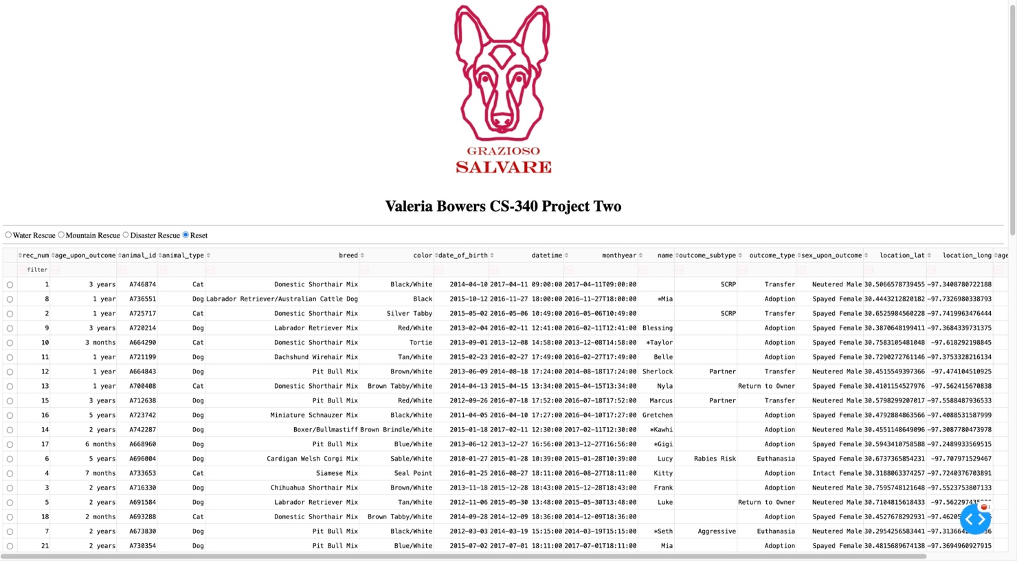

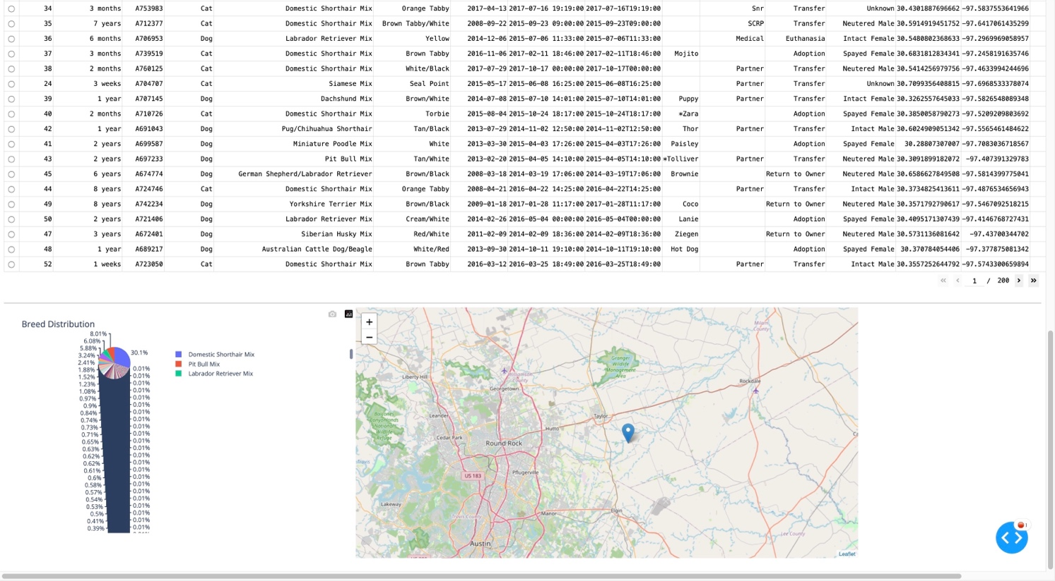

Water Rescue
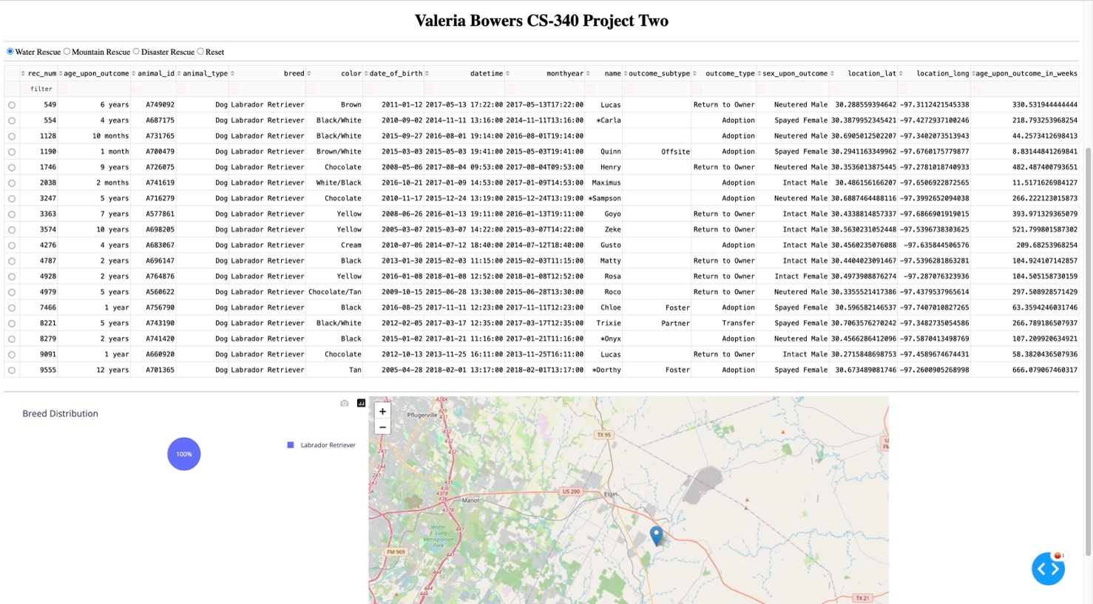

Mountain Rescue
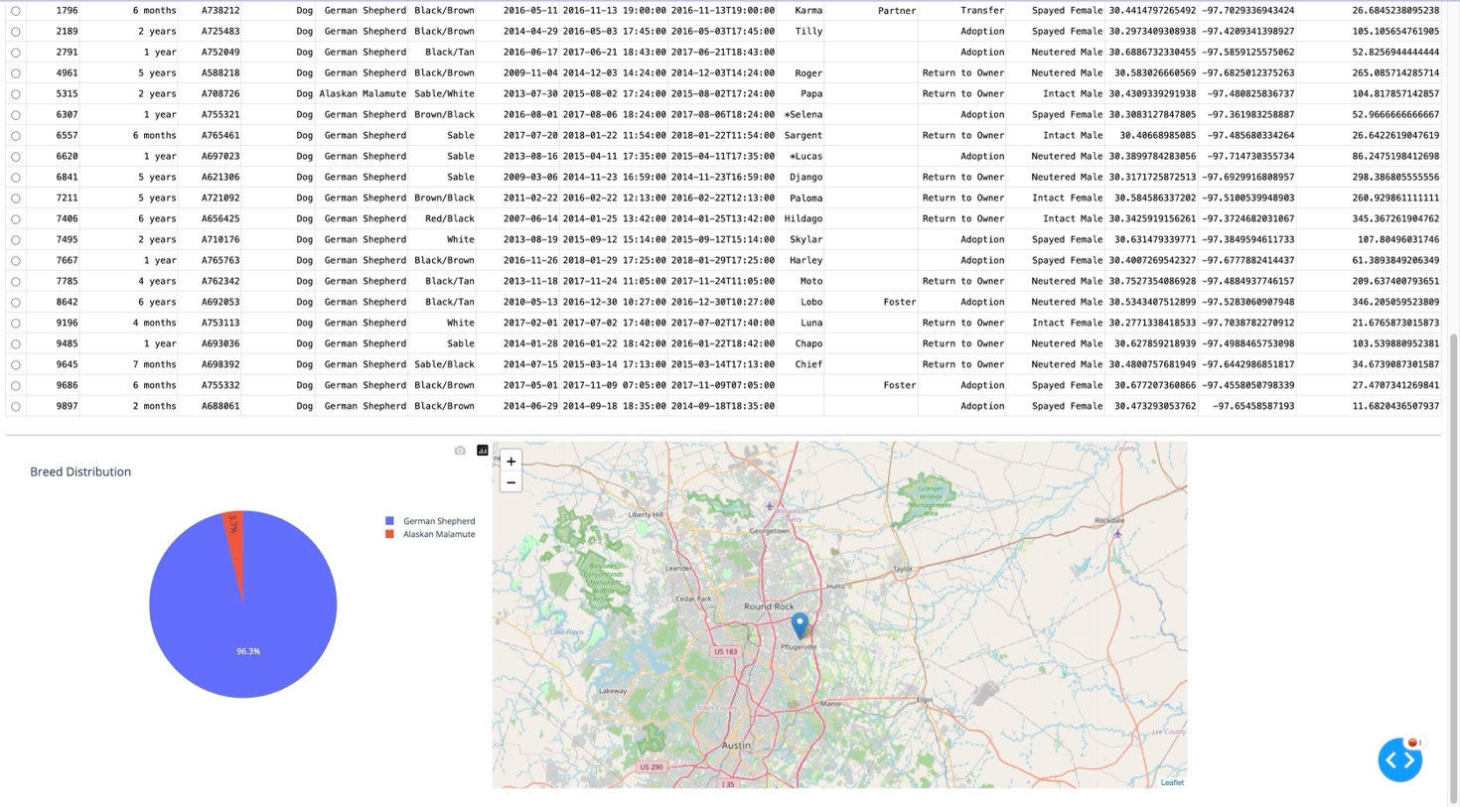

Disaster Rescue
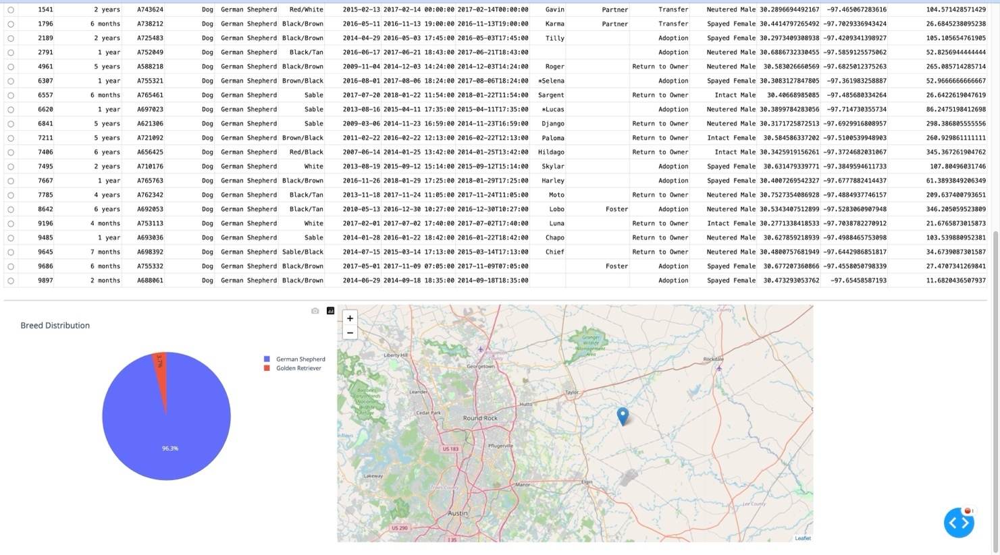

Reset
